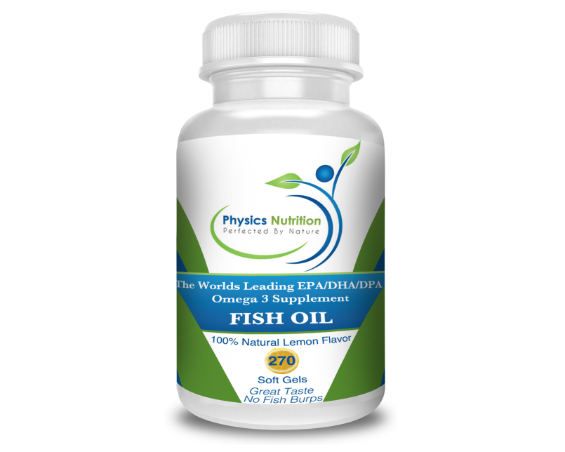
There is so much confusion, even among health professionals, when it comes to fish oil. I often see clients who are taking fish oil based on the recommendations of their doctor. The problem is that most doctors tell them to just pick up any fish oil because they are all the same. The most common recommendation for everyone is 1000 mg twice daily. I think it’s safe to say that a 250 pound male would require quite a bit more fish oil than a 100 pound female.

The fact is there is a huge difference from one fish oil to the next. Some are great and will definitely improve your health while others are terrible, can actually damage your health, and often give you that lovely fish-burp after taste.

So what exactly is fish oil and do we really need it?

There are certain nutrients that are classified as essential. Essential means that they are nutrients we need to survive and the only way to get these nutrients is by consuming them. Omega-3 fats are essential fats that humans need to consume in order to be healthy. Fatty fish and wild grass fed meats are excellent sources of these omega-3 fats. The problem is people rarely eat wild fish or wild raised meats on a regular basis and are woefully deficient in omega-3 fats.

If you are deficient in an essential nutrient there is no possible way you can be at your maximum health potential. A person doesn’t have to be showing symptoms to be deficient in a nutrient. In fact, it is very un-wise to wait until you are symptomatic before making healthier choices. A great example is a heart attack. The first symptom of a heart attack is usually a heart attack. It doesn’t make much sense to wait for that symptom before you decide to improve your diet, exercise, lose weight and do all the necessary heart disease preventative measures.

Symptoms of omega-3 fatty acid deficiency include fatigue, poor memory, dry skin, heart problems, aches and pains, joint stiffness, mood swings or depression, poor circulation, and more. Does it make sense to wait for symptoms to appear before deciding to make sure you are sufficient in a required nutrient? Unfortunately, approximately 99% of Americans are deficient in these omega-3 fats.

The best way to get nutrients is always from whole food sources. The problem is; most fish are so polluted that eating it on a regular basis is dangerous. They recommend that people only eat from a larger fish only one meal per month, and pregnant woman should stay away completely. I’m not saying all fish are polluted but overall it is getting harder and harder to find clean fish.

The only safe way to get a sufficient amount of omega-3 fats is from “quality” supplementation. It is really sad when you think about how badly we have, and continue to, pollute our environment. In the 1960’s the Cuyahoga River in Ohio was so polluted it started on fire… at least 13 times! A RIVER started on FIRE 13 times! That is what it took for the government to start the Environmental Protection Agency.

Now the absolute best way to get your omega-3 fats would be from eating pollution-free fish on a regular basis. There is a boat load of evidence showing the benefit of doing so. The fat (oil) that is in wild fish is the best source of omega-3’s. The fish oil in wild fish is in the most natural, most absorbable, and most beneficial form and concentration for people. Of course it’s perfect, that is how we have been getting our omega-3’s for millions of years. The best fish oil supplements are the ones that squeeze the oil from fish, filter out any pollutants, keep it fresh, and sell it in the exact form and concentration you would find it in nature. Very few fish oil supplements actually do this.

Rule #1 – If you don’t see “Natural Triglyceride Form” on the bottle, don’t buy it.
If you were to go shopping for olive oil, would you rather get olive oil that is certified organic and freshly cold pressed from the olives then bottled OR would you rather the oil be spoiled and biochemically altered in a lab before bottling? The vast majority of fish oil you see on store shelves is biochemically altered fish oil that doesn’t exist in the tissues of any living creature on the planet. In fish, all omega-3 fats are in a triglyceride molecular form. That is the form that is the most natural, most absorb-able, and most beneficial to us. In the process of cleaning the fish oil to remove toxins the triglyceride molecule is broken into an ethyl ester. Ethyl ester fish oil does not exist in any food source on the planet. It is expensive to convert the ethyl ester back to the natural triglyceride from so that step is usually skipped. This is very important. We have never improved a nutrient. The way it exists in nature is always the best.
Rule #2 – If you get fish burps, throw it away!
What about the nasty fish oil burps? Fish oil is very easily oxidized, which means it spoils very quickly. If you’ve ever caught a fish you know it doesn’t have a nasty fishy odor to it. However, if you leave that fish lay out for a bit it won’t take long before it starts smelling ripe. If you bought the cheap fish oil at a Walgreens and got some nasty fish burps and fish breath, then you got yourself some rancid fish oil. No wonder it was so cheap! Rancid fish oil actually promotes inflammation, which is the opposite effect wanted. By going cheap you literally paid to cause yourself harm. A quality, 3rd party tested fish oil company will not sell rancid fish oil. Therefore you will not get the nasty fish burps or breath.

Rule #3 – If you don’t see DPA or other omega-3’s listed with EPA and DHA, do not buy it.
There are different types of omega-3 fats with the most commonly recognized being EPA (eicosapentaenoic acid) and DHA (docosahexaenoic acid). There are also other omega-3 acids like DPA (docosapentaenoic acid). Most fish oil products will only have EPA and DHA in them. You will never eat a piece of fish that only has EPA and DHA. Wild fish has ALL the omega 3-fats that are important to health. Remember, consuming a nutrient the way it exists in nature is ALWAYS the best.

Rule #4 – If the product is concentrated in any way, do not buy it.
Also, the ratio of EPA/DHA is always 3/2. You will never find a high DHA fish swimming around or a high EPA fish. They always have both and in a 3/2 ratio of EPA/DHA with all other omega-3 fats. Fish oil companies will often concentrate one or the other based purely on clever marketing, not on improving health or sufficiency.

Rule #5 – Make sure you are actually buying fish oil and not fillers.
A really common trick I see is fish oil companies will boldly print 1,000 mg per serving on the front of the bottle. Then, when you look at the ingredients you will see 300 mg of fish oil and 700 mg of soybean oil. It is so hard to trust vitamin companies when they do such blatantly deceiving marketing.

Rule #6 – Animal source omega-3 fats are much better than plant source.
What about plant sources of omega-3 fats like flax seed oil? Plant source omega -3 fats are in the ALA (alpha linolenic) form. The ALA form of omega-3 fats are not a usable form by the human body. It must be converted in the body to EPA, DHA and other omega-3’s. This is a very difficult conversion for the body to do and only a tiny percentage is converted. It is virtually impossible to be sufficient in omega-3 fats from plant sources. Sorry vegans. When you look at the history of humans this makes perfect sense. We weren’t roaming the wilderness looking for flax and chia seeds to munch on. We were consuming fish and herbivores on a regular basis which have the ability to convert ALA to EPA/DHA/DPA and store it in their tissues.

What about the studies/articles I read online that say fish oil doesn’t actually help or the doctor blog posts that say don’t take fish oil just eat fish?

The answer is actually very simple. The studies that show fish oil doesn’t work is because in the study they use the ethyl ester, or concentrated or fractioned low quality fish oil. Of course it’s not going to work. When a poor quality product is used in a study you can’t make the conclusion that it is all bad. Those studies always end with “fish oil doesn’t benefit health but eating fish fat does.” Quality fish oil is literally fish fat that has been filtered and put in a bottle. It is fish. How could it possibly not be of benefit when it literally is the exact same nutrient you would get from eating fish, just cleaner?

Another problem with some studies is that the study is poorly designed and forms an incorrect conclusion. You will see studies where people with heart disease are given a regimen of fish oil, almost always poor quality fish oil. The people with heart disease won’t see a drastic improvement in heart disease outcomes and conclude that fish oil doesn’t help. This blanket conclusion of “not helping at all” cannot be made. If a person is deficient in an essential nutrient, then that person is not as healthy as he/she could be.

It doesn’t matter if symptoms are present or not. If you are deficient in the essential nutrients from omega-3 fats and after supplementing you become sufficient, you are without question healthier. This is true with or without the presence of symptoms. If a person is a little bit dehydrated but not yet showing any symptoms, wouldn’t it still be healthier if he/she was fully hydrated? It would be foolish to wait until cotton mouth and muscle cramping really set in before deciding to have a drink. Just because fish oil didn’t cure their heart disease, doesn’t mean they didn’t get healthier!

A study by Mozaffarian 1, is a primary prevention study. “These authors looked at subjects without prevalent coronary heart disease (CHD), stroke, or heart failure. These authors studied whether or not consuming more omega 3 fatty acids increased health status and prevented illness and death. Guess what they found?

Higher circulating individual and total omega-3 PUFA levels are associated with lower total mortality, especially CHD death, in older adults. Let me paraphrase.The subjects who had more sufficient dietary intake of omega-3 fatty acids lived longer and had a significantly decreased chance of dying from heart disease. However, the truth is that even if this were not the finding it would not mean that supplementation with omega-3 fatty acids was not necessary. These people could have died from heart disease or other deaths caused by factors unrelated to omega-3 fatty acids. The take home point is that if a nutrient is essential it is a requirement for health. No ands, ifs, buts, or maybes.” (Dr James Chestnut)

There is plenty of research showing the benefits of consuming omega 3 fats.
• A study at the University of South Australia showed that taking fish oil combined with moderate exercise over 12 weeks boosted weight loss. (Hill, Am J Clin Nutr, Vol 85, 2007, 1267-74). The researchers determined that the fish oil activated enzymes responsible for burning fat!
• Eating fatty fish is shown to lower blood pressure, lower cholesterol, lower neuronal inflammation, reduce depression symptoms, elevate immune response and increased Brain Derived Neurotrophic Factor. (Dr. J. Ratey “Spark”)

A high quality fish oil is especially important for women who are planning to get pregnant, pregnant, or nursing. Omega 3 fats are critical components in the function of brain cells. Without them the cells don’t function very well. A fetus will be producing up to 8,000 new cells per second! That is amazing. If you don’t get enough omega 3’s studies show, the baby is at much greater risk for dyslexia, ADHD, depression, bipolar disorder, and schizophrenia. A study done by Harvard showed that pregnant mothers that got more omega 3’s had smarter babies than those who didn’t. These studies can be found in a great book “Brain Rules for Baby” by molecular developmental biologist John Medina.

I cannot emphasize this enough. It can’t be just any fish oil. The cheap fish oil from Walmart or the stuff your buddy sells as part of some Multi-Level-Marketing (MLM) company will not help. I have yet to see a high quality MLM fish oil. There are two things you should never bargain shop for; products that can affect your health and toilet paper. This is a side rant but that cheap super thin public restroom toilet paper should be banned.

One of the most foolish, yet common, things I see in people is waiting for symptoms to appear before looking to make a change. I have seen little kids with a huge cookie and sugary drink in their hand. I of course ask the parents if they are concerned about all the sugar the child is eating. The response is usually that “it’s ok, the child is skinny.” So, the plan is to wait until the child is overweight before deciding not to feed them non-nutrient containing, sugar filled foods?
It is much wiser to make healthy decisions immediately and not experience symptoms than waiting until symptoms are present and deciding to try and fix it.

The next time you go shopping for fish oil or someone tries selling you fish oil make sure to ask:
- Is it in the naturally occurring triglyceride form?
- Is the product 3rd party tested for purity?
- Is the product concentrated?
- Are there any fillers added to the fish oil?
- Is it molecularly distilled to remove toxins?
- Is the product infused with natural antioxidants ensuring freshness?

It is best to take with a meal and spread throughout the day. However, if you forget and take them all at once that is perfectly fine. Remember, fish oil is food. If you are really nervous about any hint of fish taste put your capsules in the freezer. By the time they melt in your body they’ll be further down.

1) Mozaffarian, D. et al.Plasma Phospholipid Long-Chain n-3 Fatty Acids and Total and Cause-Specific Mortality in Older Adults.Annal Intern Med. 2013; 158:515-525

